1. Let  and . Both functions are continuous at *x* = *a*. Given that , Find  Note: This is an easy algebraic manipulation, however please note that you must make a **clear reasoning about continuity** in your working steps
2. Find the derivative involving the following inverse trigonometric functions:

a. b.  c. 

1. Find the derivative of the following functions using help of natural base logarithm : You need not to simplify the result a. b.  c. 
2. Identify the points of max, min, inflection and interval in which the functions below increasing, decreasing, concave up or concave down.

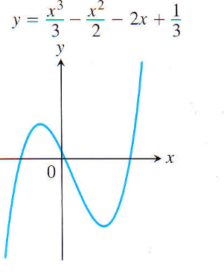 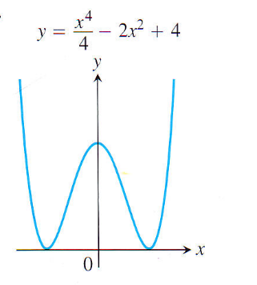 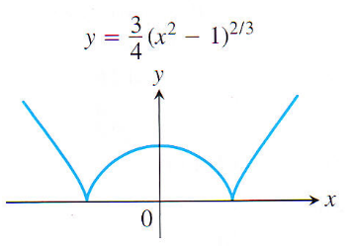 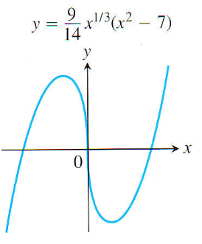

1. Find the absolute/global maxima and minima of the following functions

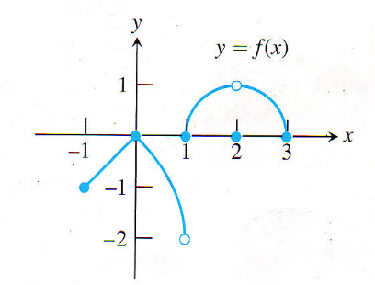 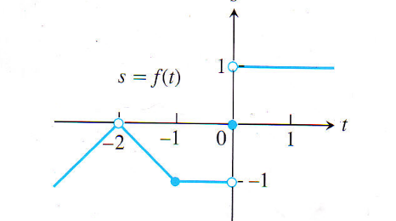

1. The function *f*(*x*) and *g*(*x*) and their derivatives are defined at two points and is shown at the following table

|  |  |  |
| --- | --- | --- |
|  | at *x* = 2 | at *x* = 3 |
| *f*(*x*) | 1 | -2 |
| *g*(*x*) | 3 | 2 |
| *f* ‘(*x*) | -2 | -1 |
| *g* ’(*x*) | 2 | 4 |

Using the table above, and the chain rule, quotient rule, product rule find the **first** **derivative** of the following functions:  at *x* = 3 b.  at *x* = 2

1. Josephine wants to get from point A located in the sea to point Y located on a stretch of beach. P is the point on the beach nearest to A such that AP = 2 km and PY = 2 km. She does this by swimming in a straight line to a point Q located on the beach and then running to Y

|  |  |
| --- | --- |
|  | (Hint: time = distance / speed)  When she swims, she covers 1 km in  minutes. When she runs, she covers 1 km in 5 minutes |

1. If PQ = *x* km where 0 ≤ *x* ≤ 2, find an expression for the time *T* (minutes) taken by Jo to reach point Y.
2. Show that  and using this find one extreme value of *T*
3. Show that  and hence show that the extreme value of *T* found above in part b is a minimum value (Hint: if *f*”(*x*) > 0 it is minimum and if *f*”(*x* ) < 0 it is maximum)
4. Find the absolute maximum and the absolute minimum values of the function f(x,y) = 2x2 + y2 – 4x – 2y + 3 on the rectangle D={(x,y)|0 ≤ x ≤ 3, 0 ≤ y ≤ 2}. Ans: Abs min=0 at (1,1), abs max=9 at (3,0) and (3,2).
5. A box with a square base (without top) is to be made from zinc plate with volume of 32 cm3, find the dimension of the box in order to minimize the material. Find the minimum material required.
6. Find the area bounded by *x*-axis , the graph  and , vertical lines *x* = -1 and *x* =5
7. The region bounded by the curve  and the lines *x* = 1, *x* = e, *y* = 0 is rotated through 360o about the *x*-axis. Find the volume generated. (hint: use partial integration)
8. Determine the surface area of the solid obtained by rotating  where  about the *x*-axis.



1. Check whether or not this sequence is convergent.



1. Check whether or not this series is convergent.



$\int{2xcos5xdx}$

$\int{\frac{dx}{x^{2}\sqrt{4+x^{2}}}}$

3. Check the convergence of:

a.

b.

9. Find Taylor series about x = 2 of f(x) = 4 Ln x

10. Find the area bounded by y = 2 – 2/3 x, y = 1 and x = 3.

Find the volume if the previous area is rotated about y=1.

Exercise

1. a. Find  b. 

2. Find dy/dx from:

a.  b. 

3. Draw y = x3 – 6x2 + 9x – 4 by finding its extreme points and inflection points if any.

4. If f(x,y) = e2x.sin y + e3y.cos x, find:

a.  b.  c.  d.  e. 

5. A box without top has a volume of 32 liters. Find the dimensions of the box such that the material required for making it is minimized.

**Exercise-1**

1. a.  b. 
2. Find the area bounded by x = 10 – y2, x = (y – 2)2.
3. a. Check the convergence of the following series:



b. (i) Find the McLaurin series of 

(ii) Find the interval of convergence of part (i)

1. Determine the interval of convergence of 
2. Find the solutions of the following ODE:
3. (2x+y+1)dx + (2y+x+1)dy = 0.
4. , with boundary value y(1) = 0.

**Exercise-2**

1. a.  b. 

2. Find the area bounded by y = 4 + x – x2, y = 1 – x.

3. a. Check the convergence of the following series:



b. (i) Find the McLaurin series of 

(ii) Find the interval of convergence of part (i)

1. Determine the interval of convergence of 

5. Find the solutions of the following ODE:

a. e3x(3x2y+2xy+y3)dx + e3x(x2+y2)dy = 0.

b. .

**Exercise-3**

1 a.  b. 

2. Find the area bounded by y = 3x – x2, y = 2x3 – x2 – 5x.

3. a. Check the convergence of the following series:



b. (i) Find the McLaurin series of 

(ii) Find the interval of convergence of part (i)

4. Determine the interval of convergence of 

5. Find the solutions of the following ODE:

a. yex.dx + (2y+ex+1)dy = 0.

b. .

c. y’ + (tan x).y = cos2x, y(0)=2.

**Exercise-4**

1. a.  b. 

2. D is the area bounded by , x=0, y=3.

a. Find the area of D

b. Find the volume if D is rotated about y axis.

3 a. Check the convergence of: 

b. Determine the interval of convergence of 

4. Find the first 5 terms of McLaurin series of 

5. Solve the following ODE:

a. (x + e–x.sin y)dx – (y + e–x.cos y)dy = 0.

b. 

**Exercise-5**

1. a. b. 

2. a. Find the area bounded by y = x2, y=4.

b. Find the volume of revolution of part (a) about y axis.

3. Check the convergence of:

a. 

b. 

4. a. Find the McLaurin series for f(x) = ln (x+1)

b. Find the interval of convergence.

5. Solve the following ODE

a. (2x+3y+4)dx + (3x+4y+5)dy=0.

b. 

**Exercise-6**

1. Solve ODE: 

2. Find the area bounded by x = y2 and x – y – 6 = 0.

3. Find McLaurin series for  (4 non-zero terms)

4. Find the interval of convergence of 

5. Evaluate the following integrals:

a.  b. 

**Exercise-7**

1. Solve: 

2. Evaluate the following integrals:

a.  b. 

3. Find McLaurin series for  (4 non-zero terms)

4. Find the interval of convergence of 

5. Find the area bounded by 

**Exercise-8**

1. Solve: 

2. Evaluate the following integrals:

a.  b. 

3. Find McLaurin series for  (4 non-zero terms)

4. Find the interval of convergence of 

5. Find the area bounded by .

**Short Semester Exercise**

1. a. Find  b. 

c.  d.  e. 

2. Find dy/dx from:

a.  b.  c. 

3. Draw y = x3 – 6x2 + 9x – 4 by finding its extreme points and inflection points if any.

Equation:

$y=x^{3}-6x^{2}+9x-4$

$$y^{'}=3x^{2}-12x+9 \\ y^{'}=x^{2}-4x+3 \\ y^{'}=\left(x-3\right)\left(x-1\right) \\ x=3 ∪x=1$$

$$\min{({3,3}^{3}-6×3^{2}+9}×3-4) \\ \min\left(3,27-54+27-4\right) \\ min⁡(3,-4)$$

$$\max\left({1,1}^{3}-6×1^{2}+9×1-4\right) \\ \max\left(1,1-6+9-4\right) \\ max(1,0)$$

Find inflection point $$y" = dy/dx(y') \\ y" = 6x -12 \\ 0=6x-12 \\ 12=6x \\ x=2 \\ inflection\left({2,2}^{3}-6×2^{2}+9×2-4\right) \\ inflection\left(2,8-24+18-4\right) \\ inflection\left(2,-2\right)$$

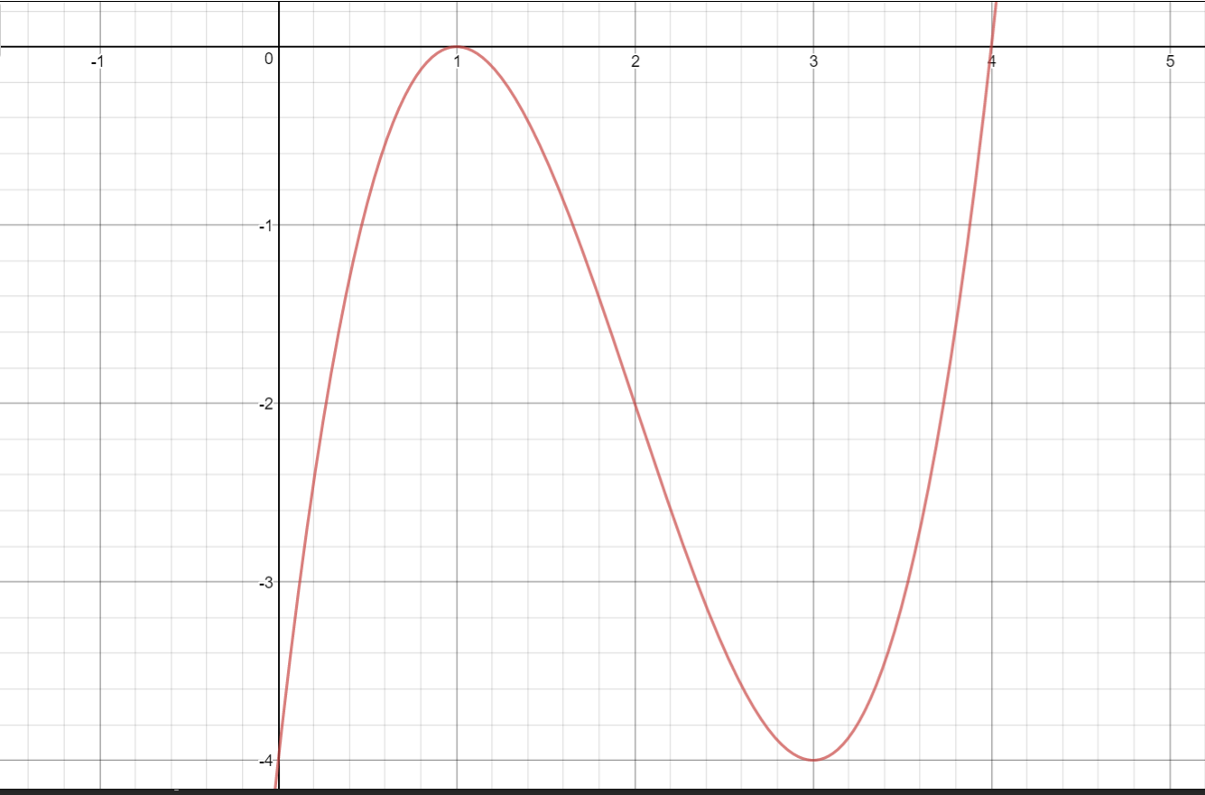

|  |  |  |  |  |
| --- | --- | --- | --- | --- |
| x | 0 | 1 | 3 | 4 |
| y | -4 | 0 | -4 | 0 |

4. The perimeter of a rectangle is 56 cm. Find the dimensions if the area should be maximized and find the maximum area.

5. If f(x,y) = e2x.sin y + e3y.cos x, find:

a.  b.  c.  d.  e. 

6. A box without top has a volume of 32 liters and a square base. Find the dimensions of the box such that the material required for making it is minimized.

7. A box without top has a volume of 32 liters. Find the dimensions of the box such that the material required for making it is minimized.

8. If x2 + 2y2 + 3z2 = 6, find and .

9. Find:

a.  b. 

10. Find the area bounded by

a.  b. 

11. Find the volume of solid revolution if the area bounded by y = x2 ad y = x+2 is rotated about x axis.

**Preparation for Short Semester Final Exam**

1. Evaluate the followings.

a.  b.  c. 

$\begin{aligned}lim \\ x→0\end{aligned}{\frac{2x^{2}+3x sin5x}{7x^{2}+5x\tan{4x}}}$

$$\lim{(\frac{2x^{2}}{x^{2}}+((3x\sin{5x)/x^{2} ) ) / (\frac{7x^{2}}{x^{2}}+(5x\tan{4x)/x^{2}) }}}$$

2.

a. Given . Find .

b. A garden of rectangle form has an area of 64 m2. If the garden is to be fenced find the minimum length of fence needed.

c. A garden of rectangle form has a perimeter of 64 m. If the garden is to have a maximum area, find the dimensions and the maximum area.1

3.

a. Given .

Find zx, zy, zxx, zyy, and zxy.

b. A box with an open top is to have 16000 cm3 capacity and to be made of thin sheet metal. Calculate the dimensions of the box if it is to use the minimum possible amount of metal. Find the minimum area.

c. 4x2 + 3y2 + z2 = 4. Find  and 

4.

a. Evaluate  b. Evaluate 

c. Calculate the area between  and  by drawing the curves first.

d. Find the volume of revolution if the area bounded by y = x3 and y = x is rotated about y axis.

5.

a. Check whether or not the following sequence is convergent: 

b. Check whether or not the following series is convergent: 

c. Find the interval of convergence of 

d. Find the solution of ODE: 

1. Evaluate the followings.

a.  b.  c. 

2.

a. Given . Find .

b. A garden of rectangle form has an area of 81 m2. If the garden is to be fenced find the minimum length of fence needed.

c. A garden of rectangle form has a perimeter of 28 m. If the garden is to have a maximum area, find the dimensions and the maximum area.

3.

a. Given .

Find zx, zy.

b. A box with an open top is to have 8000 cm3 capacity and to be made of thin sheet metal. Calculate the dimensions of the box if it is to use the minimum possible amount of metal. Find the minimum area.

c.  . Find zx, zy, zxx, zyy, and zxy.

4.

a. Evaluate  b. Evaluate 

c. Calculate the area between  and  by drawing the curves first.

d. Find the volume of revolution if the area bounded by y = x3 and y = 4x is rotated about y axis.

5.

a. Check whether or not the following sequence is convergent: 

b. Check whether or not the following series is convergent: 

c. Find the interval of convergence of 

d. Find the solution of ODE: 

 1.a limit aljabar,    b. limit trigono  
 2. kontinuitas dan diskontinuitas  
 3. mencari turunan dengan konsep limit  
 4. menggambar kurva dengan titik maks.min, belok  
 5. turunan parsial.

**Calculus-1**

1. a.  tanpa L’Hospital. b.  dengan L’Hospital
2. Diketahui fungsi 
3. Apakah f(x) kontinu di x = 1? Jelaskan.
4. Apakah f(x) dapat dibuat kontinu di x = 1? Jelaskan.
5. Diketahui . Carilah f ‘(x) dengan menggunakan konsep limit.
6. Gambarkan kurva y = 2x4 – 4x2 dengan mencari maks, min dan titik belok terlebih dahulu.
7. Diketahui . Carilah semua turunan parsial orde 1 dan orde 2.
8. Find a.  b. 
9. Diketahui fungsi 
10. Apakah f(x) kontinu di x = 0? Jelaskan.
11. Apakah f(x) dapat dibuat kontinu di x = 0? Jelaskan.
12. Diketahui . Carilah f ‘(x) dengan konsep limit.
13. Gambarkan kurva y = 2x3 – 9x2 + 12x dengan mencari maks, min dan titik belok terlebih dahulu.
14. Jika x2 + y2 + z2 = 4, carilah zx, zy, zxx, zyy, zxy, zyx.

**Exercise for Final Exam Calculus**

1. A.  B. 
2. Find the area bounded by , x=1, x=e, and x axis.
3. Find the McLaurin’s series of 
4. Determine the convergence of 
5. Find the solution of 

**Exercise for Final Exam Calculus**

1. Use the right method to solve the followings. (15,15 marks)
2.  b. 
3. A region is bounded by the curves y = 1 – x2 and x + y + 1 = 0. Draw the graphs and calculate the area of the region. (20 marks)
4. Given . Find the McLaurin series giving at least three non-zero terms. (15 marks)
5. Check whether or not the following series is convergent: .(15 marks)
6. Find the solution for the following ODE: with initial condition y(1)=2. (20 marks).

**Exercise for Final Exam**

1. Find  b. Find 
2. Find the first derivative of  (do not simplify)
3. An **open** top box is to have a square base and a volume of 500 cm3. Find the dimension (length, width, height) of the box that minimizes the amount of material used. Find the minimum area.
4. Total daily profit from the sale of item X and item Y is given by P(x)=30000x+21000y–10x2–10y2–10xy
5. Find the value of x and y in order to maximize the profit.
6. Find the maximum profit.
7. Evaluate 
8. Find the area bounded by the curve  and x axis.
9. Find the volume of area (b) if it is rotated about x axis.
10. Test the convergence of 
11. Find the interval of convergence of 
12. Write down the first five terms of McLaurin’s series for 

---o0o---

**Exercise for Final Exam**

1. a. Find  b. Find 
2. a. Find dy/dx of 2x2 + 3xy + y2 + 4x + 2y – 12 = 0 at point (1,1)

b. An **open** top box is to have a square base and a volume of 864 cm3. Find the dimension (length, width, height) of the box that minimizes the amount of material used. Find the minimum area.

1. Total daily profit from the sale of item X and item Y is given by P(x,y)= 30x+21y–x2–y2–xy (million rp). Find the value of x and y in order to maximize the profit. Find the maximum profit.
2. A. Evaluate 

B. Find the area bounded by x = y and x = y2 .

C. Find the volume if area no B is rotated about y axis

1. A. Test the convergence of 

B. Find the interval of convergence of 

C. Write down the four non-zero terms of Taylor’s series for f(x) = ln x at x = 1

---o0o---

**Exercise for Final Exam**

1. a. Find  b. Find 
2. a. Find dy/dx of 

b. An **open** top box is to have a square base and a volume of 2048 cm3. Find the dimension (length, width, height) of the box that minimizes the amount of material used. Find the minimum area.

1. Total daily profit from the sale of item X and item Y is given by P(x,y)= 23x+4y–3x2–4y2+xy+20 (million rp). Find the value of x and y in order to maximize the profit. Find the maximum profit.
2. A. Evaluate 

B. Find the area bounded by y = 4x, y = x3 in the first quadrant.

C. Find the volume if area no B is rotated about x axis

1. A. Test the convergence of 

B. Find the interval of convergence of 

C. Write down the four non-zero terms of McLaurin’s series for f(x) = ln (x+1).

---o0o---

**Exercise for Midterm Test**

1. Find the following limits.

a. 

b. 

1. Find the first derivative of:

a. 

b. (2x – 3y)2 = 5x + 3y – 1.

1. Sketch the curve y = x2(6 – x) by finding max, min, inflection if any.

a. Find the first partial derivatives of: 

b. Find the first and second partial derivatives of z = x4 + y4 + 2x2y2 – 1.

c. Given x4 + y4 + z4 + x2y2z2 =4. Find  and  at point (1,1,1).

5. a. A homeowner has a long strip of 70 cm wide metal and wants to make a rain gutter by folding the sides up to form a rectangular cross-section with an open top shown in below figure. Where should she fold to get the maximum cross-sectional area? Find the maximum cross-sectional area.

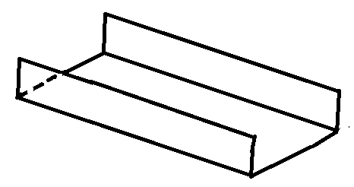

b. A container with open top has a volume of 32 liter. Find the dimension such that the material used to build it is a minimum. Find the minimum material used.

6. a. Find dy/dx for y = x2 + 3x using limit.

b. Does f(x) =  have a limit at point x = 4? Explain.

c. Find the point of discontinuity of f(x) = 

d. Is f(x) = x2/3 differentiable at x = 0? Explain.

7. The diagram below shows the path that Wilson follows every morning to take water from the river to his farm. Help Wilson minimize the total distance travelled from his house to the farm.

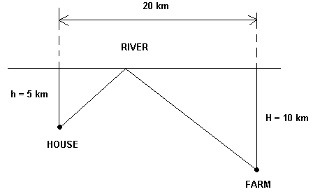

8. Total revenue of two goods is: TR=30x+21y–x2–y2–xy (million rp). Find:

1. x and y (in units) if TR is to be maximized
2. Maximum total revenue

9. Find

a.  b. 

1. Find 5 non-zero terms of Mc Laurin series for f(x) = 

2. Find the area bounded by y = 2x2 + 10, y = 4x + 16, x = –2 , x = 5.

3. Find: a.  b. 

4. Determine the convergence of 

5. Find the solution of , given y(0)=1.

6. Find the solution of 

7. Test for convergence: 

8. Find: a.  b. 

9. Find the area bounded by , , and x axis

10. Find 5 non-zero terms of Mc Laurin series for .

11. a.  b. 

12. Find 4 non-zero terms of Mc Laurin series for .

13. a. Check the convergence of 

b. Find the interval of convergence of 

14. Find the solution of (2x + y + 3) dx + (x + 2y – 1) dy = 0, y(0)=2.

15. a. Find the area bounded by y = ln x, x axis and x = e.

b. Find the volume of revolution if the area of part (a) is rotated

about x axis.

1. Solve:

a.  b. 

1. Using integral, find the area bounded by y=3x, y=x and x=1.
2. Check the convergence of .
3. Give the 4 non-zero terms of f(x) = .
4. Find the solution of separable ODE: , at point (0,3).

**Exercise for Mid-term Test**

1. Given .

a. Find the lim of f(x) as x approaching 3

b. Is f(x) continuous at x=3? Explain.

c. How to define f(x) such that f(x) is continuous at x=3?

1. Find the first derivative (dy/dx) of:

a. 

b. (2x – 5y)2 = 4x + 3y – 26

1. Draw the curve of  by finding the x intercepts, y intercept, max, min, and inflection points if any.
2. A. Find  and  from  at point (1, 1, 1)

B. Find all partial derivatives of order 1 and order 2 of: 

1. In the diagram below, *PQRS* is a rectangle such that *SR* = 6 metres and *PS* = 5 metres. A triangle *SAB*, where the angle *SAB* is a right-angle, is drawn inside the rectangle so that *A* lies on *PQ* and *B* lies on *QR*. *AQ* = *x* metres and *BQ* = *y* metres.

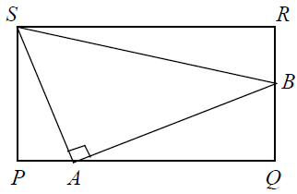

1. Find the maximum length of QB.
2. Find the maximum area of triangle QAB.
3. The diagram below shows the path that Wilson follows every morning to take water from the river to his farm. Help Wilson minimize the total distance travelled from his house to the farm.

